Glaucoma detection using Machine Learning – VGG16 Model

Abstract: Glaucoma is a very common eye problem. If people can know about it at earlier stage then it would be helpful for them to treat it early to recover early. Otherwise in severe cases eye can be fully blind by this disease. Machine Learning strategies uses to design and development of algorithms and models to detect and predict the future results or analyse through the data in iterative process. In Machine Learning, CNN is used for image data, this is effective on varies medical data such as fundus image, MRI, CT scans, X-rays, Histopathology slides etc. We have study about 8134 images as training data, 400 for validation, 1000 images for testing. By applying CNN model on large amount of data , we have got 0.8890 as test accuracy on our designed model. Machine learning model detects the progressing eyes earlier than other techniques.In this study, we have got test loss 0.9833, test accuracy 0.8095, test precision 0.8570, test recall 0.7640, test AUC 0.8960, test F1 Score 13.4369, validation loss 0.9346, validation accuracy 0.8375, validation precision 0.8566, validation recall 0.8100, validation AUC 0.9205, validation F1 Score 13.8001. We have also get Receiver Operating Characteristic(ROC) curve, confusion matrix to evaluating result.

Introduction:
Glaucoma is a disease which can be caused of blindness of people. It can permanently take the lights from people forever. So it is important to be cured at the early stage otherwise it could be the cause of people blindness. It is a common eye disease now a days. People at any age can be affected by it. But patients who are 60 plus aged are in the most risked stage by that disease.
Glaucoma is a chronic optic nerve disorder characterized by the progressive degeneration of retinal ganglion cells and their axons, which produces measurable visual field defects [1] . A primary risk factor for glaucoma is intraocular pressure (IOP), it can assert mechanical strain on the lamina cribrosa, ultimately disrupting axoplasmic transport [2]. However, axonal damage in glaucoma may still be present among individuals with normal IOP levels, and individuals with identical IOP readings may present with diverse predispositions to developing the disease. This emphasizes the multifaceted and neurodegenerative nature of glaucoma. Multiple potential sources of its development include aging, inflammatory processes [3], and immune mechanisms—such as the function of heat shock proteins and localized immune responses [4–8].
Because the progressive death of retinal ganglion cells is a distinguishing feature of glaucoma, the disease displays comparable features with other neurodegenerative conditions like Alzheimer’s disease [9]. Remarkably, a population-based cohort study has demonstrated a statistically significant adjustment between glaucoma and Alzheimer’s, suggesting an underlying link between neurodegeneration in the central nervous system and the retina [10,11].
In our analysis, we applied machine learning algorithms to clinical data, which we segmented into training, validation, and test sets for performance evaluation. The model's accuracy was determined based on the test data, and we constructed a confusion matrix to distinguish between glaucomatous and healthy cases. We study about both cases in our research and analysis the results.

Related work:
While intraocular pressure (IOP) is a well-established risk factor,by itself, it does not adequately predict the development of glaucoma. Nevertheless, analyzing comorbid conditions has emerged as a useful additional technique for early-stage glaucoma detection [12]. For instance, Joanne et al. found that people living with systemic conditions such as diabetes have a 2.8 times higher likelihood of developing glaucoma compared to those without diabetes [13]. Similarly, Deokule et al. highlighted that vascular diseases, particularly coronary artery disease, are affiliated with glaucoma risk and may act as potential prognostic indicators [14]. Supporting this, large-scale cross-sectional studies such as the Egna-Neumarkt Glaucoma Study, the Rotterdam Eye Study, and the Blue Mountain Eye Study have identified an association between elevated blood pressure and increased glaucoma prevalence [14–16].
On the other hand, medical management of systemic diseases like diabetes and hypertension could have a sophisticated influence on glaucoma onset—an area that has not been thoroughly investigated in longitudinal or cross-sectional designs. It's important to note that most previous studies relied on knowledge-driven or hypothesis-based approaches, often incorporating a limited number of predefined variables in their predictive analyses.
With the widespread adoption of electronic health records (EHRs) and their increasing use in secondary research [17], there is now a compelling opportunity to adopt an evidence-based approach for developing predictive models. These models can help uncover how comorbidities and their treatments influence glaucoma onset. EHRs hold a wealth of clinical data that can be utilized in multiple ways, including clinical decision support [18], identification of prognostic markers [19], and comprehensive risk assessment [20].
In recent years, machine learning (ML) techniques have shown considerable promise in a wide range of fields, including clinical data analysis, image classification, diagnostic modeling, and decision-making support systems [21]. For example, Bertsimas et al. successfully combined unsupervised and supervised ML algorithms to forecast near-future healthcare expenditures for patients [22]. ML strategies have also seen use in EHR data to enhance the prediction of risk factors for glaucoma, cataract surgery complications, and diabetic retinopathy [23–26]. Additional studies have analyzed the connections between various risk factors and outcomes such as postoperative visual acuity [27,28].
In the field of ophthalmic imaging, Almazroa et al. demonstrated that automated glaucoma detection using fundus photographs has the potential to be effective [29]. A systematic review further highlighted the range of ML techniques applied to glaucoma diagnosis, progression tracking, and risk evaluation employing medical imaging techniques [26]. These imaging techniques can detect molecular-level changes that have previously manifested within the ocular tissues. Bragança et al., in a recent study, applied deep learning on smartphone-based fundus images captured via handheld ophthalmoscopes and demonstrated an accuracy rate of approximately 90% in glaucoma detection [30].
In comparison to image-based approaches, EHR-based models focus on predicting glaucoma onset by analyzing patients’ comorbidity histories. Notably, Baxter et al. used machine learning models built on EHR data to predict the necessity for surgical intervention for glaucoma. Their model showed promising results in predicting surgical needs up to six months in advance [31].

About Dataset:
Standardized Multi-Channel Dataset for Glaucoma (SMDG-19) is a collection and standardization of 19 public datasets, comprised of full-fundus glaucoma images, associated image metadata like, optic disc segmentation, optic cup segmentation, blood vessel segmentation, and any provided per-instance text metadata like sex and age. This dataset is designed to be exploratory and open-ended with multiple use cases and no established training/validation/test cases. This dataset is the largest public repository of fundus images with glaucoma.

Dataset Objective
The objective of this dataset is a machine learning-ready dataset for glaucoma-related applications. Using the help of the community, new open-source glaucoma datasets will be reviewed for standardization and inclusion in this dataset.

Data Standardization
Full fundus images (and corresponding segmentation maps) are standardized using a novel algorithm (Citation 1) by cropping the background, centering the fundus image, padding missing information, and resizing to 512x512 pixels. This standardization ensures that the most amount of foreground information is prevalent during the resizing process for machine-learning-ready image processing.
Each available metadata text is standardized by provided each fundus image as a row and each fundus attribute as a column in a CSV file

Methodology:
We have take 8134 images as training data, 400 images for validation data, and 1000 images for testing data.

Glaucoma is a group of disease which damages optic nerve of eyes. If this disease be untreated then it able to take the vision loss of our eyes. So it is very important to detect earlier and start the treatment at the early stage. In our study, we have taken previous data to analyze them with Machine Learning techniques to detect the healthy eye and glaucoma affected eye. In figure-1, we have made a CNN based architecture, which helps us to do step by step whole detection process of healthy and glaucoma eye. In figure-2, we have get the CNN all layers which applied in our study step by step. Glaucoma is the leading eye problem globally. So it should be treated earlier to not get any more complicated situation and not be blind at the early age.
At first it will take input fundus images. Then it crops the background of that images.It will center the fundus image. Padding is being added to cover missing information about specific image. Resizing the images to get better result. It rezises as 512*512 pixels.
Then the visualization Part, it includes CNN architecture model training, testing, validation in feature extraction. It involves model evaluation. Then get confusion matrix, accuracy in the result part.
Convolutional Neural Network (CNN) is a part of deep learning model, which works with grid-like data(e.g., Images). It is designed to adapt to learn spatial hierarchies of features through convolutional layers. It accepts the raw images as input images. In convolutional layer, it applies kernels that slide over the input to extract the features. Then it gets the feature map. Then uses padding to control image size. Activation function is applied to introduce non-linearity to the function. Then the pooling layers come to reduces the spatial dimensions of the feature maps. It helps to keep the important features while reducing overfitting. In this pooling layers, commonly used is Max pooling which takes the maximum value in a region, we have used max pooling in our study. Other pooling layers can be used is average pooling, which takes the average value of the study. CNNs can have multiple conv+pool blocks. It helps to get more accurate result for our study. Then used flattening Layer which converts the final pooled feature maps into a 1D vector, which involves with fully connected layers.Then Dense(Fully connected layers) come at the end of CNNs. It combines extracted features to make predictions of the model. Finally the output layers consists of classification of our model. In out study, we have used sigmoid (binary classification) which indicated glaucoma or healthy eyes.

Here is the proposed architecture to detect glaucoma and healthy eye using Machine Learning technique:

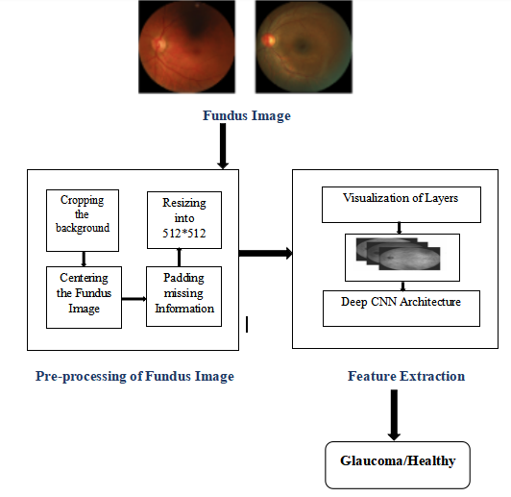
Figure-1: The proposed CNN architecture to detect Glaucoma eye disease

CNN used for image classification, object detection, medical image analysis(like detecting glaucoma from retinal scans).It consists various layers, here we have given the model used in our study:
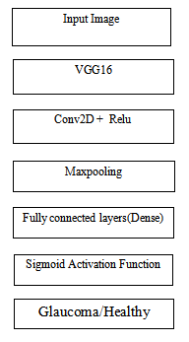
Figure-2: CNN model used here
This is for training dataset sample, 0 indicates healthy eyes:
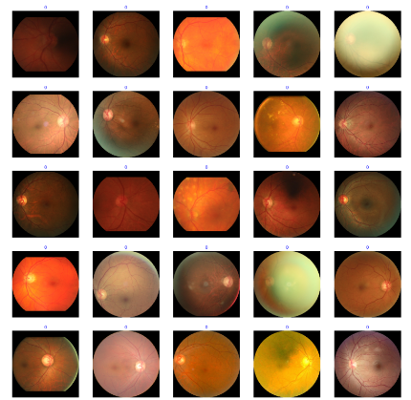
Figure-3: Sample for test dataset(0 means glaucoma absent)
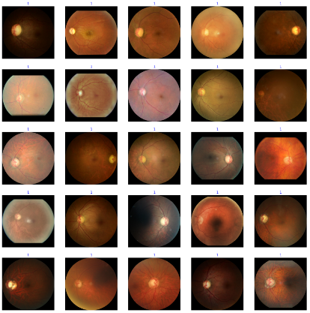Figure-4: Sample for training dataset(1 means glaucoma present)

Result:
Using “relu” activation function, a dense layer that is fully connected to each layer, then “relu” activation function again, and lastly “sigmoid” activation function for healthy or glaucoma detection. Using VGG16, which is a convolutional neural network(CNN) architecture. It is used for computer vision and image classification. It has a simple yet effective design, characterized by its depth (16 layers with weights- 13 convolutional layers and 3 fully connected layers). It also uses small 3*3 convolutional filters. Model for this study:
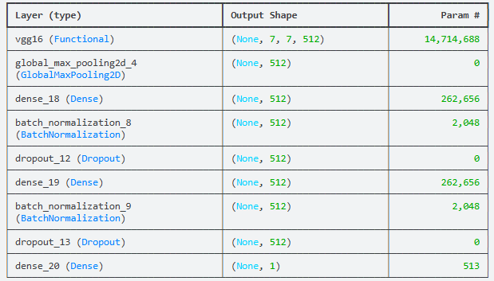
Figure-5: Model used for our study
For test classification, we have got test loss 0.9833, test accuracy 0.8095, test precision 0.8570, test recall 0.7640, test AUC 0.8960, test F1 Score 13.4369.
Classification Report:

Traits | Precision | Recall | f1- score | Support
Healthy | 0.78 | 0.86 | 0.82 | 500
Glaucoma | 0.85 | 0.75 | 0.80 | 500
Accuracy |  |  | 0.81 | 1000
Macro avg | 0.81 | 0.81 | 0.81 | 1000
Weighted avg | 0.81 | 0.81 | 0.81 | 1000

Table-1: Test classification report

For Validation classification, we have got validation loss 0.9346, validation accuracy 0.8375, validation precision 0.8566, validation recall 0.8100, validation AUC 0.9205, validation F1 Score 13.8001.
Classification Report:

Traits | Precision | Recall | f1- score | Support
Healthy | 0.81 | 0.85 | 0.83 | 200
Glaucoma | 0.85 | 0.80 | 0.82 | 200
Accuracy |  |  | 0.83 | 400
Macro avg | 0.83 | 0.83 | 0.83 | 400
Weighted avg | 0.83 | 0.83 | 0.83 | 400

Table-2: Validation Classification Report

ROC (Receiver Operating Characteristic) Curve includes False Positive Rate (FPR) at x-axis, True Positive Rate (TPR) at Y-axis:
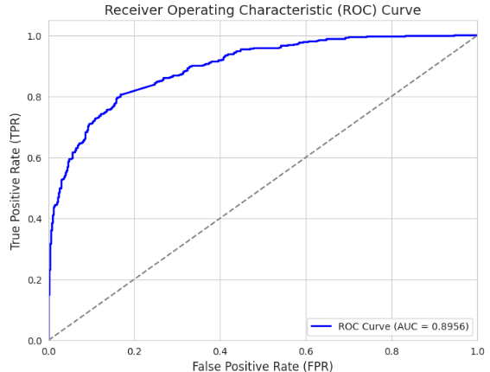
Figure-6: Receiver Operating Characteristic (ROC) curve

Confusion Matrix, which indicates healthy and glaucoma:

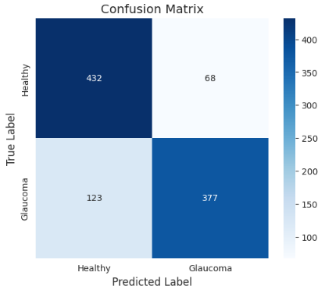
Figure-7: Confusion Matrix
Training, Validation and Test Loss- where red is for test loss, green is for validation loss, blue is for test loss:
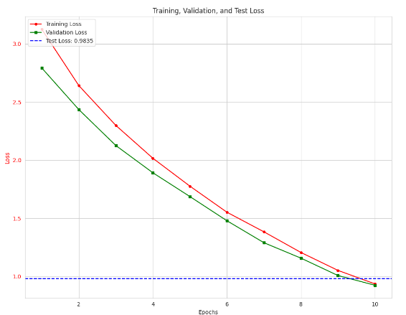
Figure-8: Training, Validation, and Test Loss

Training, Validation and Test Accuracy- where orange is for test accuracy, blue is for validation accuracy, purple is for test accuracy:

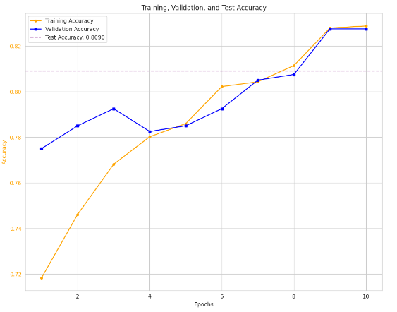

Figure-9: Training, Validation and Test Accuracy

We study about glaucoma detection using Machine Learning. We have took training, validation and testing data. We use CNN architecture to detect the glaucoma and healthy eye. In our study, we have got test loss 0.9833, test accuracy 0.8095, test precision 0.8570, test recall 0.7640, test AUC 0.8960, test F1 Score 13.4369, validation loss 0.9346, validation accuracy 0.8375, validation precision 0.8566, validation recall 0.8100, validation AUC 0.9205, validation F1 Score 13.8001.

Discussion
The application of deep learning like convolutional neural networks (CNNs) has been advanced in the field of medical image analysis. In this study we have applied VGG16 architecture for the detection of glaucoma from retinal fundus images. Our model shown strong effective which reaching high accuracy, sensitivity, and specificity compared to conventional image processing and machine learning approaches. This outcome is reliable with previous findings in ophthalmic AI research, where deep CNNs have shown more effective at capturing important features compared to hand-designed methods.
A major strengths of VGG16 lies in its deep layered architecture with small receptive fields (3×3 kernels) which enabling the network to capture subtle structural changes in the optic nerve head and retinal nerve fiber layer, this both critical indicators of glaucomatous damage. Transfer learning further enhanced the model’s generalization ability. It is reducing the need for very large annotated datasets, which are often scarce in medical imaging.
Have these advantages but also have some limitations that should be noted. VGG16 is being a relatively heavy model. VGG16 requires notable computational resources for training and inference which is cause of limit its direct application in low-resource clinical environments. Additionally, model performance like CNN is highly dependent on dataset quality and diversity. Retinal images from different devices also lighting conditions, and patient demographics could impact external validity.
In our study we have got by analyzing our proposed model, we have got test loss 0.9833, test accuracy 0.8095, test precision 0.8570, test recall 0.7640, test AUC 0.8960, test F1 Score 13.4369, validation loss 0.9346, validation accuracy 0.8375, validation precision 0.8566, validation recall 0.8100, validation AUC 0.9205, validation F1 Score 13.8001. We have also get Receiver Operating Characteristic(ROC) curve, confusion matrix to evaluating result of our study.

Conclusion And Future work
This research highlights the effectiveness of VGG16 in automated glaucoma detection from retinal fundus images as input data. The model’s ability to learn informative features offer as a robust tool for early diagnosis. Which is crucial for preventing irreversible vision loss. While the results are encouraging then the further improvements can be achieved by combining VGG16 with advanced architectures, employing larger multi-ethnic datasets, and integrating explainable AI techniques to enhance clinical acceptance all over the world.
In conclusion we can say that deep learning-based approaches which exemplified by VGG16, hold great potential in transforming glaucoma screening and diagnosis using old data. With continued refinement and clinical validation, this types of models can support ophthalmologists in timely decision-making earlier, improve patient outcomes, and ultimately contribute to reducing the global burden of blindness caused by glaucoma.

References:
- Quigley HA. Glaucoma. Lancet. 2011;377 (9774):1367–1377.
[2] Fechtner RD, Khouri AS. Evolving global risk assessment of ocular hypertension to
glaucoma. Curr Opin Ophthalmol. 2007;18(2):104–109.
[3] Nayyar A, Gindina S, Barron A, et al. Do epigenetic changes caused by commensal microbiota contribute to development of ocular disease? A review of evidence. Hum Genomics. 2020;14(1):11.
[4] Chen H, Cho KS, Vu THK, et al. Commensal microflora-induced T cell responses
mediate progressive neurodegeneration in glaucoma. Nat Commun.
2018;9(1):3209.
[5] Polla D, Astafurov K, Hawy E, et al. A pilot study to evaluate the oral microbiome and dental health in primary open-Angle glaucoma. J Glaucoma. 2017;26(4):320–327.
[6] Gupta A. Harnessing the microbiome in glaucoma and uveitis. Med Hypotheses. 2015;85(5):699–700.
[7] Astafurov K, Elhawy E, Ren L, et al. Oral microbiome link to neurodegeneration in glaucoma. PLoS One. 2014;9(9):e104416.
[8] Wax MB, Tezel G, Saito I, et al. Anti-Ro/SS-A positivity and heat shock protein antibodies in patients with normal-pressure glaucoma. Am J Ophthalmol.
1998;125(2):145–157.
[9] Almasieh M, Wilson AM, Morquette B, et al. The molecular basis of retinal ganglion cell death in glaucoma. Prog Retin Eye Res. 2012;31:152–181.
[10] Ramirez AI, de Hoz R, Salobrar-Garcia E, et al. The role of Microglia in retinal neurodegeneration: Alzheimer’s disease, Parkinson, and glaucoma. Front Aging Neurosci. 2017;9:214.
[11] Lin IC, Wang YH, Wang TJ, et al. Glaucoma, Alzheimer’s disease, and Parkinson’s disease: an 8-year population-based follow-up study. PLoS One.
2014;9(10):e108938.
[12]Harasymowycz, P.; Birt, C.; Gooi, P.; Heckler, L.; Hutnik, C.; Jinapriya, D.; Shuba, L.; Yan, D.; Day, R. Medical Management of Glaucoma in the 21st Century from a Canadian Perspective. J. Ophthalmol. 2016, 2016, 6509809. [CrossRef]
[13] Katz, J.; Sommer, A. Risk factors for primary open angle glaucoma. Am. J. Prev. Med. 1988, 4, 110–114. [CrossRef]
[14] Deokule, S.; Weinreb, R.N. Relationships among systemic blood pressure, intraocular pressure, and open-angle glaucoma. Can. J. Ophthalmol. 2008, 43, 302–307. [CrossRef]
[15] Dielemans, I.; Vingerling, J.R.; Algra, D.; Hofman, A.; Grobbee, D.E.; de Jong, P.T. Primary open-angle glaucoma, intraocular pressure, and systemic blood pressure in the general elderly population. The Rotterdam Study. Ophthalmology 1995, 102, 54–60.
[CrossRef]
[16] Bonomi, L.; Marchini, G.; Marraffa, M.; Bernardi, P.; Morbio, R.; Varotto, A. Vascular risk factors for primary open angle glaucoma: The Egna-Neumarkt Study. Ophthalmology 2000, 107, 1287–1293. [CrossRef]
[17] Safran, C.; Bloomrosen, M.; Hammond, W.E.; Labkoff, S.; Markel-Fox, S.; Tang, P.C.; Detmer, D.E.; Expert, P. Toward a national framework for the secondary use of health data: An American Medical Informatics Association White Paper. J. Am. Med. Inf. Assoc. 2007, 14, 1–9. [CrossRef]
[18] Kuperman, G.J.; Bobb, A.; Payne, T.H.; Avery, A.J.; Gandhi, T.K.; Burns, G.; Classen, D.C.; Bates, D.W. Medication-related clinical decision support in computerized provider order entry systems: A review. J. Am. Med. Inf. Assoc. 2007, 14, 29–40. [CrossRef]
[19] Jiang, M.; Chen, Y.; Liu, M.; Rosenbloom, S.T.; Mani, S.; Denny, J.C.; Xu, H. A study of machine-learning-based approaches to extract clinical entities and their assertions from discharge summaries. J. Am. Med. Inf. Assoc. 2011, 18, 601–606. [CrossRef]
[20] Persell, S.D.; Dunne, A.P.; Lloyd-Jones, D.M.; Baker, D.W. Electronic health record-based cardiac risk assessment and identification of unmet preventive needs. Med. Care 2009, 47, 418–424. [CrossRef]
[21] Kononenko, I. Machine learning for medical diagnosis: History, state of the art and perspective. Artif. Intell. Med. 2001, 23, 89–109. [CrossRef] [PubMed]
[22] Bertsimas, D.; Bjarnadóttir, M.V.; Kane, M.A.; Kryder, J.C.; Pandey, R.; Vempala, S.; Wang, G. Algorithmic prediction of healthcare costs. Oper. Res. 2008, 56, 1382–1392. [CrossRef]
[23] Akter, N.; Fletcher, J.; Perry, S.; Simunovic, M.P.; Briggs, N.; Roy, M. Glaucoma diagnosis using multi-feature analysis and a deep learning technique. Sci. Rep. 2022, 12, 8064. [CrossRef]
[24] Saleh, E.; Blaszczynski, J.; Moreno, A.; Valls, A.; Romero-Aroca, P.; de la Riva-Fernandez, S.; Slowinski, R. Learning ensemble classifiers for diabetic retinopathy assessment. Artif. Intell. Med. 2018, 85, 50–63. [CrossRef]
[25] Fraccaro, P.; Nicolo, M.; Bonetto, M.; Giacomini, M.; Weller, P.; Traverso, C.E.; Prosperi, M.; OSullivan, D. Combining macula clinical signs and patient characteristics for age-related macular degeneration diagnosis: A machine learning approach. BMC
Ophthalmol. 2015, 15, 10. [CrossRef] [PubMed]
[26] Omkar, G.K.; Elaine, W.G.; David, F.; Landon, G. Evaluating machine learning classifers for glaucoma referral decision support in primary care settings. Sci. Rep. 2022, 12, 8518.
[27] Lundström, M.; Goh, P.-P.; Henry, Y.; Salowi, M.A.; Barry, P.; Manning, S.; Rosen, P.; Stenevi, U. The changing pattern of cataract surgery indications: A 5-year study of 2 cataract surgery databases. Ophthalmology 2015, 122, 31–38. [CrossRef]
[28] Lundström, M.; Barry, P.; Henry, Y.; Rosen, P.; Stenevi, U. Visual outcome of cataract surgery; study from the European Registry of Quality Outcomes for Cataract and Refractive Surgery. J. Cataract. Refract. Surg. 2013, 39, 673–679. [CrossRef]
[29] Almazroa, A.; Alodhayb, S.; Raahemifar, K.; Lakshminarayanan, V. An automatic image processing system for glaucoma screening. Int. J. Biomed. Imaging 2017, 2017, 4826385. [CrossRef]
[30] Bragança, C.P.; Torres, J.M.; Soares, C.P.; Macedo, L.O. Detection of Glaucoma on Fundus Images Using Deep Learning on a New Image Set Obtained with a Smartphone and Handheld Ophthalmoscope. Healthcare 2022, 10, 2345. [CrossRef]
[31] Baxter, S.L.; Marks, C.; Kuo, T.T.; Ohno-Machado, L.; Weinreb, R.N. Machine Learning-Based Predictive Modeling of Surgical Intervention in Glaucoma Using Systemic Data From Electronic Health Records. Am. J. Ophthalmol. 2019, 208, 30–40. [CrossRef]
[PubMed

